User Manual
Application for registration for fresh/renewal of trade/Storage License is to be submitted through online system with requisite documents & registration & processing fee.
For ease of applicant, registration can be made through CSB center at zonal office by submitting the requisite documents & fee.
Document Required: following scanned of original documents are required at the time of submitting online application.
- Proof of Legal occupancy of the establishment or allotment letter of Govt. agency/tenancy proof/ Electricity/ water connection bill/ Landline Telephone bill/ Lease Deed/GPA.
- ID Proof (with Photograph) i.e. Aadhar Card/ Voter ID/ Pan Card/ Valid Indian Passport/ Permanent Driving License/ Bank Pass book with photograph and signature.
- Photograph of the establishment with front-facia, Display of goods traded from the premises or the business being carried out from the premises.
- Copy of the PAN/VAT/TIN(if available).
- Site plan/Key Plan Showing the area under the occupation of the application or earmarking salient feature of the neighborhood of the site.
- Photograph of the Proprietor/authorize signature.
Registration/Processing Fee:-The registration and processing fee Rs. 1100/- alongwith license fee Payable through net banking/Credit Card/Debit Card by the applicant at the time of submission of online application and at zonal CSB counters of South DMC before final submission of online application from for getting General Trade/Storage License u/s 417 of DMC Act, 1957 which is non-refundable.
Filling up the application form:-
STEP-I
All the fielded marked with ‘*’ are Mandatory/Compulsory and applicant need to fill these filled, to get the license
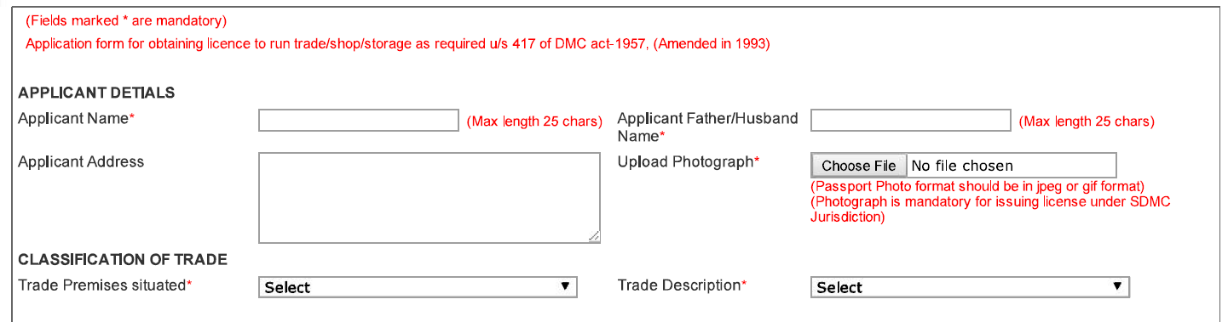
- Applicant Details
- Application Name : Name of the applicant (Proprietor or Authorize Person)
- Applicant Father/Husband Name: As Applicable.
- Applicant Address: Residence Address of Applicant.
- Upload Photograph: Passport size Photograph
(Screenshot of photograph uploading)
- Classification of Trade
i. Trade Premises Situated: select the Trade premises situated at where license is required (Annexure 1)
ii. Trade Description: Select the Name of the Trade as per (Annexure 2)
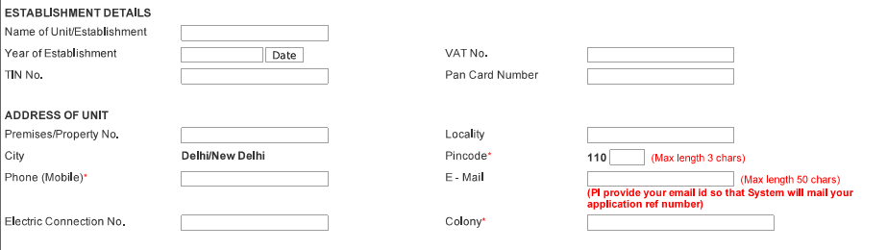

- Establishment details:-
- Name of Unit/Establishment: Name of the firm/Business/Company/Shop.
- Year of Establishment with date: Year of Business Started at the premises.
- VAT No: Enter the VAT number of the firm/business.
- TIN No: Enter the Tin Number of the Firm.
- PAN No.: PAN number of the Proprietor/Firm/Business.

- Address of Unit:-
- Premises/Property No.
- Locality: Street/Road etc.
- Colony: Name of the colony
- Pin Code:
- Mobile no.: Mandatory (It is suggested to fill the permanent mobile No., as all information will be shared in future on this mobile No. first).
- E-mail ID: Application is also suggested to fill the permanent e-mail, as all information will be shared in future on this e-mail first).
- Electric Connection No.: Mandatory.

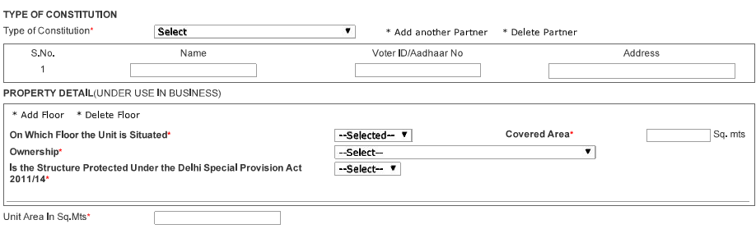

Type of trade
- Type of constitution: Select the appropriate Proprietorship/Partner Ship/Pvt. LTD/Ltd etc.
- Fill the details of Persons as per the constitution of the firm.

- Property Details: Application need to provide the following details of the premises for which license is applied:
- On which Floor the Unit is situated:
- Coverd Area:
- Ownership:
- Is the structure Procted under the Delhi Special Provision Act 2011/2014:

- Details of Municipal Taxes/Other Taxes (if any)
- Property Tax Paid : Yes/No
- Conversion Charges Paid: Yes/No

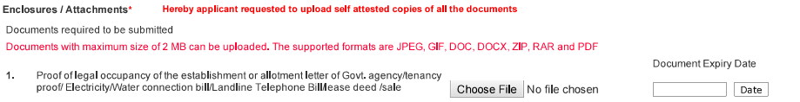
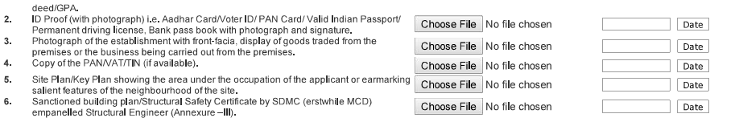
- Status of Street/Road/RoW (Right of Way):
- Classification of Trade:
- Trade Category: 1. General, 2. Special Trade(Annexure 2)
- Trade Description: Name Trade as per (Annexure 3)
- List of Prohibited Trade(as per MPD 2021): Trade Not Permissible In SDMC Area (Annexure
- Property Details (under use in Business): Describe the details regarding area which is used for business (floor wise)
- Details of Municipal Taxes/Other Taxes (if any)
- Transfer of Existing Trade license (if Necessary)
STEP-II
Uploading the Document:-
- Click on the Choose file button and select the relevant file from the scan document.
- Enter the Document expiry date if any.
- Repeat the procedure for all the document.
STEP-III
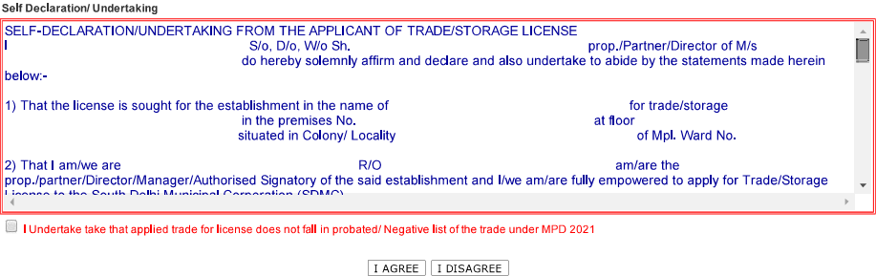
- Read the Terms & Conditions carefully.
- Click on the checkbox to declare that, “The applied license does not fall in prohibited/Negative/Hazardous List under the trade under MPD-2021”.

- On click of ‘I Agree’ button application will display the total fee payable. As:

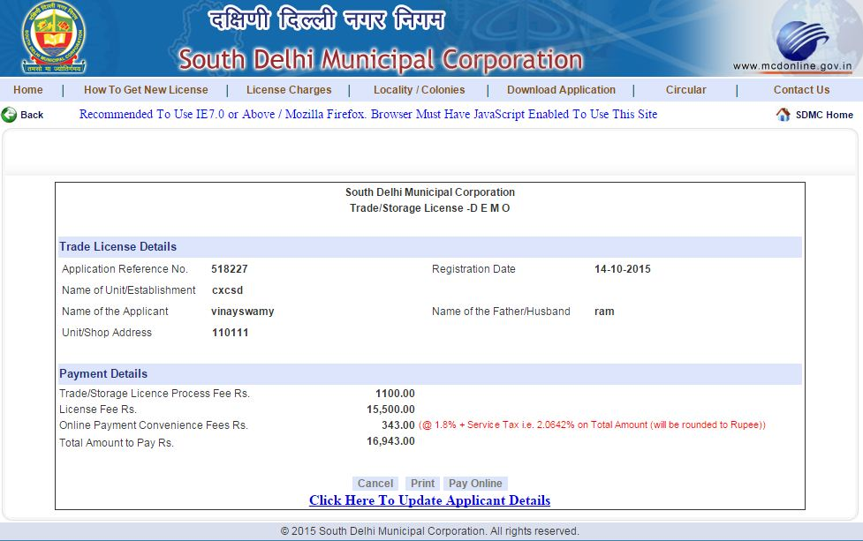

STEP-IV
Applicant need to click on the pay-online button/link for online payment: Application will be take you to the Bank/Pay gateway site.
Note: Please follow the instructions carefully to make the payment.
Online Payment of fee: Applicant have to pay the Registration/Processing fee of Rs.1100/- along with applicable license fee as per the online General Trade/Storage License Policy, 2015 through net banking/Credit Card/Debit Card.
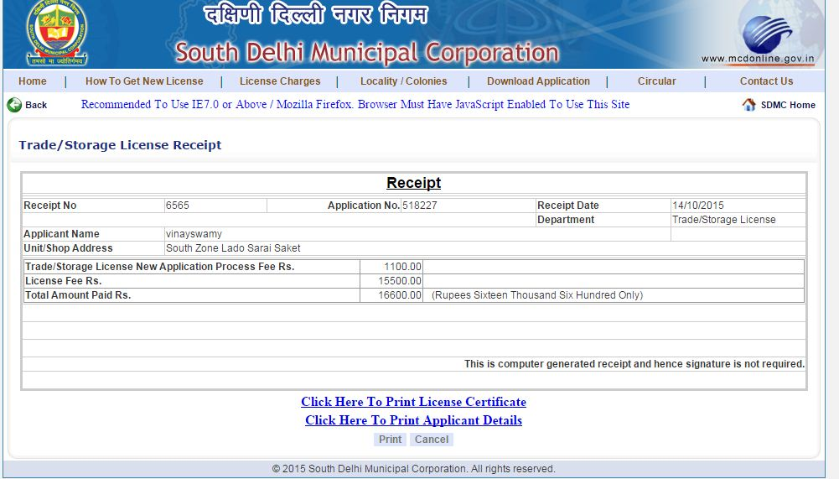
*On successful payment applicant can download the License Certificate.
*On click of Print License Certificate applicant can download the License Certificate
Note:
- Applicants who are willing to submit the application form through CSB Center at zonal offices of South DMC are advised to download the specimen application form, and fill the same as per above guidelines for convenience and so that no mistake can occur and saving their time.
- Applicants are also advised to fill all the information carefully, as application once submitted no correction will be allowed at later stage after submission. If any information is found to be incorrect/false, South DMC shall cancel the application and forfeit registration/licence fees without any notice.

Annexures
Annexure-1
Type of Habitation

- Urban Village
- Rural Village
- Unauth. Regularized Colony
- Unauthorized Colony
- J.J. Colony
- Resettlement Colony
- Dairy Complex
- Residential Area
- Notified Mixed/Land use Road
- Notified Commercial Road
- Notified Pedestrian Shopping Street
- Commercial Area
- Distt. Centre
- Local/Shopping Centre
- Convenient Shopping Centre
- Commercial Centre
- CBD/Sub-CBD
- Metropolitan City Centre
- Non-Hierarchical Commercial/Centre
- Special Area
- Industrial Area
- Household industry
- Flatted Industry
- Shop/Kiosk/Any Site allotted by Govt. Agency

Annexure-2
Trade Category

Annexure-3
Example for Calculation of License Fee and Total Amount to be Paid
Schedule of Licence fee |  |  |  |  | Example for License Fee Calculation |  |  |  |  |  | Fee to be Paid
 |  |  |  | Maximum Fee in a year in respect of single license | Total Area in Sq. Mtr Applied for | Charges for upto 10 Sq. Mtr | Charges for 10 Sq. Mtr to 20 Sq. | Charges for more then 20 Sq. Mtr | Fee Calculated | License Fee To be paid | Trade/ Storage Licence Process Fee Rs. | Online Payment Convenience Fee Rs. | Total Amount to Pay Rs.
 | (in Rs.) | (in Rs.) | (in Rs.) | (in Rs.) | (in Rs.) | (in Rs.) | (in Rs.) | (in Rs.) | (in Rs.) | (in Rs.) | (in Rs.) | (in Rs.) | (in Rs.)
 |  |  |  |  | A | B | C | D | E | F | G | H | I
 |  |  |  |  |  |  |  | A - 20 X 125 | B+C+D |  |  | @1.8% + Service tax @14%
A & B | 3000/- | 7,500/- | @ 125/- per Sq. Mtr. | 50,000/- | 9 | 3000 | 0 | 0 | 3000 | 3000 | 1100 | 84 | 4184
 |  |  |  |  | 16 | 0 | 7500 | 0 | 7500 | 7500 | 1100 | 176 | 8776
 |  |  |  |  | 80 | 0 | 7500 | 7500 | 15000 | 15000 | 1100 | 330 | 16430
 |  |  |  |  | 380 | 0 | 7500 | 45000 | 52500 | 52500 | 1100 | 1100 | 54700
 |  |  |  |  |  |  |  | A - 20 X 100 | B+C+D
C & D | 2000/- | 5000/- | @ 100/- per Sq. Mtr. | 40,000/- | 9 | 2000 | 0 | 0 | 2000 | 2000 | 1100 | 64 | 3164
 |  |  |  |  | 16 | 0 | 5000 | 0 | 5000 | 5000 | 1100 | 125 | 6225
 |  |  |  |  | 80 | 0 | 5000 | 6000 | 11000 | 11000 | 1100 | 248 | 12348
 |  |  |  |  | 380 | 0 | 5000 | 36000 | 41000 | 40000 | 1100 | 843 | 41943
 |  |  |  |  |  |  |  | A - 20 X 75 | B+C+D
E,F,G and H | 1000/- | 2500/- | @ 75/- per Sq. Mtr. | 30,000/- | 9 | 1000 | 0 | 0 | 1000 | 1000 | 1100 | 43 | 2143
 |  |  |  |  | 16 | 0 | 2500 | 0 | 2500 | 2500 | 1100 | 74 | 3674
 |  |  |  |  | 80 | 0 | 2500 | 4500 | 7000 | 7000 | 1100 | 166 | 8266
 |  |  |  |  | 390 | 0 | 2500 | 27750 | 30250 | 30000 | 1100 | 638 | 31738

